Asset Title - 3 actions to boost the impact of your agentic AI
Asset URL - https://www.ibm.com/think/insights/ai-agent-strategies
Abstract - Businesses face many challenges on their journey from AI ambition to implementation. Success requires more than adopting new technology. It involves leveraging your data, choosing the right use case, and reimagining workflows to integrate AI at the core. Leaders must ensure the right AI is applied to the right challenges. Drive Enterprise Productivity with Agentic AI That Integrates Deeper to Automate Complex Workflows.

Explore IBM’s playbook detailing three challenges and approaches you can take to help boost the impact of your agentic AI, including:

- Finding the right AI opportunity
- Creating a clear AI plan
- Integrating AI with the tools you use everyday

#ibm artifical intelligence agents, # ai agents software

CTA – Explore the Playbook



Asset Title - Start realizing ROI: A practical guide to agentic AI
Asset URL - https://www.ibm.com/downloads/documents/us-en/1443d5f5af4f532a
Abstract - Businesses are seeking real ROI with agentic AI, but many are falling short. Only 25% of the AI initiatives have delivered their expected ROI and only 16% have scaled enterprise-wide.

In this playbook, discover ways to get ahead, successfully scaling AI across your business with real results. You'll learn:

- Three common barriers to ROI on agentic AI
- How to successfully measure ROI
- An enterprise framework to scale agentic AI with real, repeatable results

Drive Enterprise Productivity with Agentic AI That Integrates Deeper to Automate Complex Workflows.
#ibm ai agent solution,# enterprise ai

CTA – Download the Guide


Asset Tite: API Holdings Scales AI-Driven Full-Stack Observability with IBM Instana
Asset URL - https://www.ibm.com/case-studies/api-holdings
Abstract - API Holdings Limited (API) — the powerhouse behind PharmEasy, Thyrocare, and Retailio — has teamed up with IBM to deploy AI‑driven full‑stack observability at scale, strengthening its digital healthcare backbone.

With IBM Instana, API now has real-time visibility across its entire tech ecosystem, helping teams detect and resolve issues faster, boost uptime, and deliver seamless healthcare experiences. The results speak for themselves — a 30% reduction in Mean Time to Resolution (MTTR) and faster innovation cycles across all three businesses. Instana’s AI-powered insights and instant alerts enable API’s engineers to focus on what matters most: building smarter, more reliable healthcare solutions.

Together, API and IBM are driving the next wave of resilient, agile, and customer-centric digital healthcare in India. Ensure Users Get Response Times They Need & IT Staff Spends Less Time Troubleshooting.
# application monitoring software,# apm solution

CTA: Explore the API–IBM success story

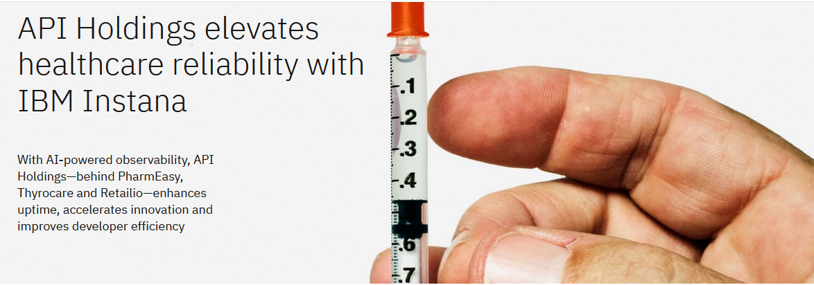

Asset Title - A DevOps guide to full-stack observability
Asset URL - https://www.ibm.com/downloads/documents/us-en/137a3e35173ed530
Abstract – Modern DevOps teams face growing complexity, data overload, and limited visibility across hybrid application environments. Full-stack observability helps overcome these challenges by offering real-time insights from user experience to infrastructure, enabling faster detection, diagnosis, and resolution of performance issues. IBM’s Instana delivers AI-powered observability across the entire technology stack—helping teams move from reactive troubleshooting to proactive optimization.

This guide empowers DevOps teams with AI-driven full-stack observability. It outlines best practices, shift-left strategies, and intelligent incident investigation to reduce downtime, improve performance, and accelerate root cause analysis—making modern application management proactive, precise, and resilient. Ensure Users Get Response Times They Need & IT Staff Spends Less Time Troubleshooting.

#instana observability,# cloud app monitoring

CTA – Download the DevOps Guide
